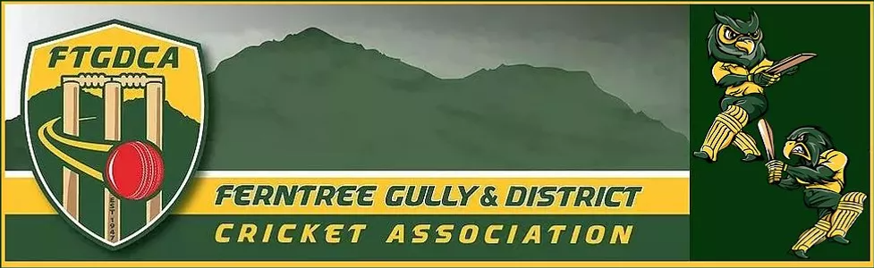
2021/22 COVID specific playing conditions – SENIORS
The following playing conditions as determined by the FTGDCA Executive replace, override or are in addition to any playing conditions that are detailed in the FTGDCA rules.
Game Day
All players, supporters and members are required to comply with the COVID Safety Plan of the home club and the association.
- Check in via Service Victoria App QR Code when arriving.
- If playing at a venue where no QR Code is available, the Captain of each side is to ensure that a manual register is completed of players and their supporters that are in attendance
- Hand sanitize when arriving.
- Home teams are to provide the hand sanitizer and alcohol wipes for both clubs. Where games are played on neutral or shared grounds and there are no facilities, each Captain is to provide hand sanitizer and wipes for their own team.
- Adhere to social distancing rules that may exist
Prior to the start of the game
- Team Sheets are not to be exchanged between teams or given to the umpires. They are to be completed and left in the scorebook or be available to be viewed on MyCricket. The Umpire and opposing Captains can elect to take a photo of the team sheet.
During the Game
- At the completion of every 20 overs, all players and umpires are to take a drinks break and required to sanitize their hands. A nominated player from the bowling side is also to sanitize the ball with an alcohol wipe. A rubbish bag is to be provided for used wipes and that bag is to be disposed of after the game.
- Umpires are not to touch the ball during the game.
- Umpires are not to hold a bowler or any players attire such as jumper and cap.
- Bowlers attire such as jumper or cap are to be placed by the bowler themselves at the nearest of the following three locations:
– Over the boundary at any point; or
– At a point at least 3m behind the keeper in line with the stumps; or
– At a point at least 3m behind the umpire at the bowlers end in line with the stumps (e.g. at the top of run-up).
- When a bowlers attire is left on the field behind the stumps as detailed in the previous bullet point, they should be placed so they are no wider than the width of the stumps and if struck the ball is declared a ‘dead ball’ and re-bowled (except for helmets and fielding equipment).
- When a wicket is taken, the ball is not to be given to the umpire. The ball is to be placed on the pitch in clear sight of the umpires.

Use of Saliva on the ball
- If a player is spotted using saliva to clean the ball, the player is to take the ball off the ground to clean the ball using an alcohol wipe. If a player elects to carry a pack of alcohol wipes onto the ground they, they can give the player an alcohol wipe rather than the player going off the ground.
- If a player repeatedly uses saliva to clean or shine a ball, the umpire will address the issue with the Captain of the fielding team to ensure that it stops. Where no official umpires are in attendance, the Captains of the teams involved are to ensure that the issue does not become one of confrontation or conflict.
- If a player or Captain makes no effort to reduce or stop using saliva on the ball
  - Where an official umpire is in attendance, the umpire will refer the matter to the umpires advisor and FTGDCA Executive.
  - Where no official umpire is in attendance, the Captain is to advise their own club COVID Safety Officer and President to refer the matter to the FTGDCA Executive
Use of Sweat on the ball
- A player may use sweat from anywhere except the head or neck region to shine the ball.
Role of Official Umpires
Official Umpires are not present to enforce COVID policies. Their only role is to ensure that the ball is cleaned every 20 overs, or cleaned should a player is discovered to be using saliva on the ball.
Drinks Breaks
- There are to be no shared drinks at scheduled drinks breaks.
- There is to be no shared food amongst the teams at any stage
- Running drinks out to batsmen or fielders during a game can only be done using drinks bottles assigned to the players. No shared drinks.
Tea Break
There is to be no shared food or shared drinks.

