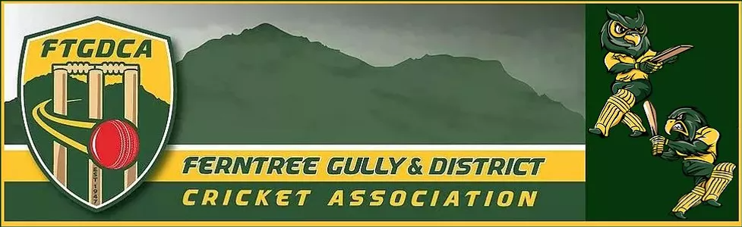
2020/21 COVID specific playing conditions – JUNIORS
The following playing conditions as determined by the FTGDCA Executive replace, override or are in addition to any playing conditions that are detailed in the FTGDCA rules.
Game Day
All players, supporters and members are required to comply with the COVID Safety Plan of the home club and the association.
- Check in via the Service Victoria QR App when arriving.
- If playing at a venue where no QR Code is available, the Coach/Team Manager of each side is to ensure that a manual register is completed of players and their supporters that are in attendance
- Hand sanitize when arriving.
- Home teams are to provide the hand sanitizer and alcohol wipes for both clubs. Where games are played on neutral or shared grounds and there are no facilities, each team is to provide hand sanitizer and wipes for their own team.
- Adhere to social distancing rules.
During the Game
- Bowling at one end – bowling spells are to be 10 overs at each end before changing ends
- For all Friday and Saturday 40 over matches, all players and umpires are required to sanitize their hands at the completion of the innings (20 overs) unless the innings has concluded earlier. A rubbish bag is to be provided for used wipes and that bag is to be disposed of after the game.
- Saturday U/16 grades (which are 50 over matches) are to take a drinks/sanitise break after 15 overs into the innings (unless the innings has already concluded) and sanitise the ball and hands at that time.
- Umpires are not to touch the ball during the game
- Umpires are not to hold a bowler or any players attire such as jumper and cap
- Bowlers attire such as jumper or cap are to be placed by the bowler themselves at the nearest of the following three locations:
– Over the boundary at any point; or
– At a point at least 3m behind the keeper in line with the stumps; or
– At a point at least 3m behind the umpire at the bowlers end in line with the stumps (e.g. at the top of run-up).
- When a bowlers attire is left on the field behind the stumps as detailed in the previous bullet point, they should be placed so they are no wider than the width of the stumps and if struck the ball is declared a ‘dead ball’ and re-bowled (except for helmets and fielding equipment).
- When a wicket is taken, the ball is not to be given to the umpire. The ball is to be placed on the pitch in clear sight of the umpires.

Use of Saliva on the ball (this will be reviewed later in the season depending upon reported frequency)
- If a player is spotted using saliva to clean the ball, the player is to take the ball off the ground to clean the ball using an alcohol wipe. If a player elects to carry a pack of alcohol wipes onto the ground they, they can give the player an alcohol wipe rather than the player going off the ground.
- If a player repeatedly uses saliva to clean or shine a ball, the umpire will address the issue with the Coach of the fielding team to ensure that it stops. Where no official umpires are in attendance, the Coaches of the teams involved are to ensure that the issue does not become one of confrontation or conflict.
- If a player or Captain or Coach makes no effort to reduce or stop using saliva on the ball, the matter is to be referred to the FTGDCA Executive.
Use of Sweat on the ball
- A player may use sweat to shine the ball from any part of the body except for the neck and face.
Official Umpires
Official Umpires are not present to enforce COVID policies. Their only role is to ensure that the ball is cleaned every 10 or 15 overs, or cleaned should a player is discovered to be using saliva on the ball.
Drinks Breaks
- There are to be no shared drinks at scheduled drinks breaks.
- There is to be no shared food amongst the teams.
- Running drinks out to batsmen or fielders during a game is to be at the absolute minimum and can only be done using drinks bottles assigned to the players. No shared drinks.

